20TH ANNIVERSARY

SOUTH ARKANSAS KENNEL CLUB DOG SHOWS & OBEDIENCE TRIALS, RALLY & LURE COURSING
FEBRUARY 23 - 24, 2019
HIGHLAND AIRPORT FACILITIES (FORMER GENERAL DYNAMICS BUILDING) 204 OUACHITA 212 (VETERANS ROAD) CAMDEN, AR
Turn left beside Dollar General in East Camden and go to the end of the road.
SHOW HOURS: Saturday 9:00 A.M. TILL 5:00 P.M. EACH DAY INDIVIDUAL BREEDS BEGIN SHOWING AT 9:00 A.M. ON SATURDAY AND 8 A.M. ON SUNDAY. GROUPS BEGIN AT APPROXIMATELY 12:30 - 1:00 P.M.
• The public is encouraged to come out and see some of the most beautiful and smartest dogs in the country.
. • Please bring your lawn chair • Sorry NO un-entered dogs allowed per AKC rules.
• Northwest Arkansas Kennel Club is joining our shows again this year hosting Lure Coursing Ability Test. This will be a fun event to watch. Two tests on Saturday and one Sunday morning
• Vendors from around the country will be there with lots of cool stuff.
- Come Hungry!! The American Cancer Society will have great home cooked food
• Admission for the dog shows is $5.00 Adults $1.00 Children 6-12 yrs of age $1.00 for Senior Citizens. Children under 6 yrs get in free.
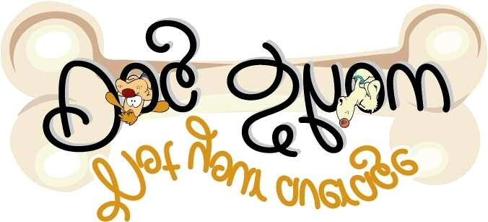
• For more info contact Darleen Wheelington, 870-818-7588 or visit www.arkansasdogs.dog to see the judging schedule for the time different breeds show. Judging schedule will be online by February 20th.

